**Cross region replication in s3**

Steps:

1. Sign in to the AWS Management Console and open the Amazon S3 console at <https://console.aws.amazon.com/s3/>.

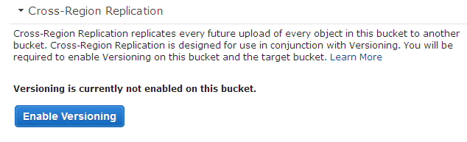

2. In the Buckets list, choose the bucket for which you want to enable cross-region replication, choose Properties, and then choose Cross-Region Replication. Choose Enable Cross-Region Replication

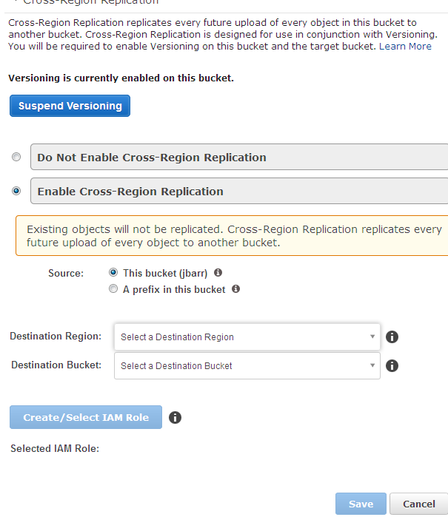

3.C hoose the Source—either the entire bucket or a prefix within the bucket.Choose the Destination Region from the drop-down list.Choose the Destination Bucket from the drop-down list. If you do not see your desired destination bucket in the list, confirm that the bucket exists in the region you selected above, and that you have enabled versioning on that bucket. If no buckets exist in that region and you click Create a new bucket from the list, you'll be prompted to create a new bucket with versioning enabled in that destination region.Optionally choose the Destination Storage Class from the drop-down list.

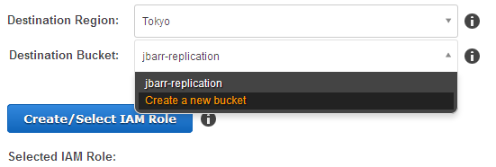

4. In order to perform cross-region replication of objects on your behalf, Amazon S3 will need to use an IAM role that you have created. Click Create/Select IAM Role and a new browser tab will open up within the AWS Identity and Access Management (IAM) console.

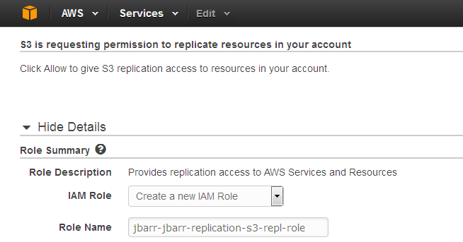

5. By default, Amazon S3 will generate a policy document for the IAM role that matches the source and destination buckets you've chosen. To continue, click Allow to return to the Amazon S3 console.and choose save

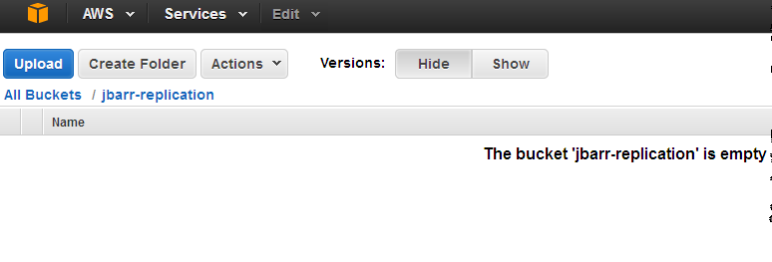

6. Upload a picture, and selected Reduced Redundancy Storage (RRS) and Server Side Encryption (SSE) using the AWS S3 master key.

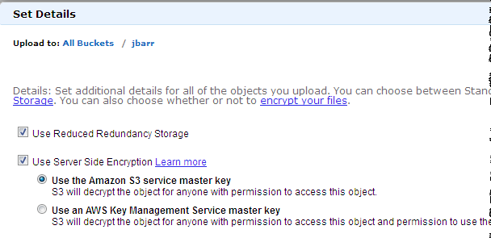

7. Refreshed my view of the destination bucket a couple of times and verified that the replica also used RRS and SSE:

